CHTC metagenomics MAG pipeline

Steps in MAG and gene relative abundance generation
-note: a and b are separating out substeps in Qijun’s pipeline. Steps I added are given .5, .75, .8, .9, .95, .99, .999, etc

Green = steps in CHTC
Yellow = steps in python (scripts are in google colabs folder)
Blue = steps in R (script is in google colabs folder)
Red = still working on this / haven’t gotten it to work yet

STEP | INPUT | OUTPUT
Step 0 trim and filter | Fastqs from lanes (from biotech folder) | Trimmed_paired fastq (1 per sample)
Step 1 remove host reads | Trimmed_paired fastq | trimmed_paired_humanDNAremoved fastq
Step 2 de novo genome assembly | trimmed_paired_humanDNAremoved fastq | assembly_out_$1.tar.gz (contains contigs fasta and orfs faa)
Step 3a map reads to contigs | assembly_out_$1.tar.gz | contig_align_$1_sorted.bam (depth file, contains relative abundance of each contig / coverage info)
Step 3b bin contigs into MAGs (based on contig nt patterns in assembly_out file, and relative abundance in bam file) | assembly_out_$1.tar.gz  contig_align_$1_sorted.bam | metabat2_out_$1.tar.gz (files including all bins / identified MAGs)
Step 3.5 make a file that only includes the MAGs (.fa files) in each sample (adding sample name to bin names so they won’t overwrite each other when they are combined) | metabat2_out_$1.tar.gz | MARS_MAG_$1.tar.gz (only all the MAGs/bins/.fa files for that sample)
Step 3.75 combine all MAG files into one tarball | MARS_MAG_$1.tar.gz | MARS_MAG.tar.gz
Step 4a run checkm | MARS_MAG.tar.gz | MAG_checkm_out.tar.gz
*transfer MAG_checkm_out (untarred) and MARS_MAG (untarred) to local computer; in windows powershell run the following python scripts, adapted from the one from Qijun: MARS_MAG.ipynb
Step 4a.5 run after_checkm.py | MAG_checkm_out | MAG_checkm_summary.tsv
Step 4a.75 run after_checkm_part2.py | MAG_checkm_summary.tsv  MARS_MAG | MARS_MAG_HQ
Step 4a.8 run after_checkm_part3.py | MAG_checkm_out folders (moved around manually, see comments in the script) | MAG_checkm_bin_stats.tsv
*move MARS_MAG_HQ back to CHTC home directory; tar it
Step 4b run drep | MARS_MAG_HQ.tar.gz | MAG_drep_out.tar.gz
*move MAG_drep_out (untarred) to local computer; in RStudio run the following R script, adapted from the one from Qijun: MAG_drep.R
Step 4b.5 run MAG_drep_011726.R | MAG_checkm_summary.tsv  MAG_checkm_bin_stats.tsv  MAG_drep_out/data_tables/Cdb.csv  MAG_drep_out/data_tables/genomeInformation.csv | MAG_drep_all.tsv  MAG_drep_winner.tsv
Step 4b.75 run after_drep.py | MAG_drep_winner.tsv | MARS_MAG_NR
*move MARS_MAG_NR back to CHTC home directory; tar it
Step 5 MAG taxonomy classification | MARS_MAG_NR.tar.gz | MAG_gtdbtk_out.tar.gz
Step 5.5 run GTDB-Tk annotation summary.py | MAG_gtdbtk_out | *MAG_gtdbtk_summary.tsv (this is the taxa)
Step 6a MAG gene identification and annotation with Prokka | MARS_MAG_NR.tar.gz | MAG_prokka_out.tar.gz
Step 6a.5 run MAG_prokka_annotation.py | MAG_prokka_out | MARS_MAG_genes.faa
Step 6b MAG gene identification and annotation with kofam | /staging/kuehn4/MARS_WGS/MARS_MAG_genes.faa | MARS_MAG_gene_kofam.tar.gz
Step 6b.5 run KEGG_kofam_annotation_summary.py | MARS_MAG_gene_kofam.tar.gz | *MAG_gene_kofam.tsv (this is the genes)
Step 6.5 annotate MAGs as putative butyrate or propionate producers based on genes in specific pathways. Start by finding fasta files for genes of interest | Vital and Reichardt papers ->  Text file from Q -> search in NCBI database and download fasta files. touch/nano [gene name].fasta and paste in the reference fasta sequences one after another | ref/{}.fasta
Step 6.5 make SCFA HMMs with hmm_012026.py | MARS_MAG_genes.faa  ref/{}.fasta | Hmm_out_scfa.csv (gives info on how well each gene in each MAG matches an HMM for any of the genes)
Pre Step 7 run prep_for_kallisto.py | MARS_MAG_NR | MARS_MAG_NR_renamed.fasta
Step 7 estimate MAG and MAG gene abundance with kallisto | Fastq files  MARS_MAG_NR_renamed.fasta | MAG_kallisto_$1.tar.gz
Step 7.5 run MAG_genome_counts_kallisto.py | MAG_kallisto_$1.tar.gz | MAG_kallisto_counts.tsv  MAG_kallisto_cpm.tsv  MAG_kallisto_tpm.tsv (these files are the relative abundances of each mag in each sample, w various types of normalization)

Note: kraken is an old method, not using anymore bc replaced w gtdb - more common db now
Note: steps 5, 6, 6.5, and 7 are independent

For step 5:

cd ~
mkdir -p software
cd software

wget https://repo.anaconda.com/miniconda/Miniconda3-latest-Linux-x86_64.sh

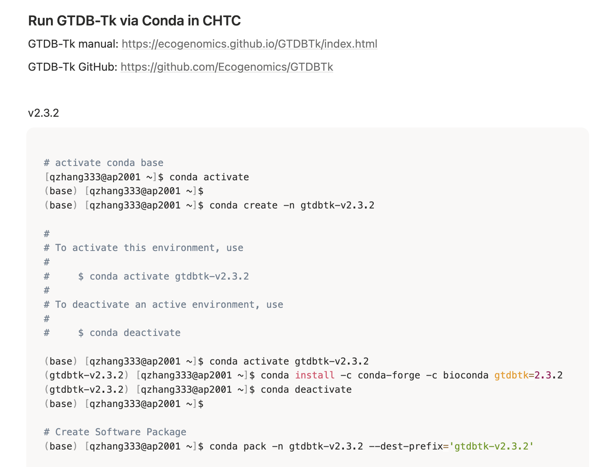
conda install -n base -c conda-forge conda-pack -y
^use this if get an error w pack line

Conda install -c conda-forge -c bioconda gtdbtk=2.3.2

For the gtdbtk database (large: 77 GB):
-he used gtdb release 214, which is the earliest one that has bacillota classifications. The one before that, release 207, is the last that uses firmicutes https://data.gtdb.ecogenomic.org/releases/
For the database:
https://data.gtdb.ecogenomic.org/releases/release214/214.0/auxillary_files/
In staging folder:
wget https://data.gtdb.ecogenomic.org/releases/release214/214.0/auxillary_files/gtdbtk_r214_data.tar.gz
Takes a while to load / several days; ideally use Q tool if can get space in chtc staging rey group datashare folder

For step 6b, need kofam profiles and ko list
ko stuff in rey_lab_datashare; downloaded from https://www.genome.jp/ftp/db/kofam/ (change the dates/file names)
And instead of compiling ruby and parallel, install them into a conda environment in home directory by making a new conda environment (cant use base bc that doesnt get transferred to worker node) earlier:
***copy the screenshot format above replacing gtd… w kofam, and using the below installs
conda install -c bioconda ruby
conda install -c bioconda parallel
conda install -c bioconda hmmer
conda install -c bioconda kofamscan
(got these by just googling conda kofamscan, etc)
*note: conda is diff from most of the sh scripts, in which we installed tools on the worker node before the lines of code for the actual job. For conda, you create the environment with the tools beforehand, so in sh script you dont need to unpack all the tools etc you just need to activate that conda environment. Follow the sh script format for the gtdbtk sh file in Q github (conda was used for that as well).

To check that:
Conda env list #lists your conda environments (I see base and gtdbtk-v2.3.2):
Then loop through each and see which contains ruby and parallel

(base) [kuehn4@ap2001 ~]$ conda env list

# conda environments:
#
# * -> active
# + -> frozen
base * /home/kuehn4/miniconda3
gtdbtk-v2.3.2 /home/kuehn4/miniconda3/envs/gtdbtk-v2.3.2

(base) [kuehn4@ap2001 ~]$ for e in $(conda env list | awk 'NF && $1 !~ /^#/ {print $1}'); do
echo "=== $e ==="
conda run -n "$e" which ruby 2>/dev/null || echo "no ruby"
conda run -n "$e" which parallel 2>/dev/null || echo "no parallel"
done
=== base ===
/home/kuehn4/miniconda3/bin/ruby

/home/kuehn4/miniconda3/bin/parallel

=== gtdbtk-v2.3.2 ===
no ruby
no parallel

*for output of step 6 - the final file is a list of pathways / KOs corresponding to gene IDs. Gene IDs correspond to a MAG, the key is in result/MAG_prokka_gene.tsv which has one column for locus tag / gene ID and one column for bin ID. For every bin ID/MAG, there are multiple locus tags / gene IDs corresponding to KO pathways. (the series of letters in the gene ID corresponds with a MAG, and the number following is numbering the genes in that MAG)
-so with some joining in R etc / data wrangling can see for each MAG, what genes/KO pathways are there

For step 6.5:
See the google doc MAG Step 6.5 SCFA HMMs + L. reuteri genes/pathways that could be involved in AD pathology, and the below ubuntu steps
#downloaded muscle in Downloads from github #https://github.com/etetoolkit/ext_apps/blob/master/src/muscle3.8.31/muscle3.8.31_i86linux64
#Actually need the windows one - downloaded the first windows one listed here, which worked
#https://drive5.com/muscle/downloads_v3.htm
#Also need hmmer
#Poss w ubuntu?
#Poss w conda?
#conda create -n hmmer_env -c bioconda -c conda-forge hmmer
#conda activate hmmer_env
#For this trying conda. To install miniconda on windows #https://www.anaconda.com/docs/getting-started/miniconda/install#quickstart-install-instructions

All of this wasn’t working - going to try doing conda in ubuntu (instead of windows powershell)
(note: Heather: I always work in ubuntu, not windows powershell) (presumably bc a lot of bioinformatics tools etc are written for linux)
-install miniconda in ubuntu

Or just try in ubuntu:
sudo apt-get install hmmer
sudo apt-get install muscle
cd /mnt/c/Users/kuehn4/Downloads
sudo apt-get update
sudo apt-get install python3-pandas
sudo apt-get install python3-biopython
python3 hmm_012026.py
*this worked!!

*for output of step 6.5 - the column tname corresponds to one gene / protein sequence (ex. Letters_number - letters correspond to a sample number, number corresponds to the gene number within that sample as annotated by prodigal/prokka). Each of these can be mapped to a mag/bin id with the MAG_prokka_gene.tsv file (like for step 6b output). The column ref_gene tells which gene the row is mapping against, ex mmdA. The column “inc”:
Number of domains satisfying inclusion thresholds. -> if >1, the mag has that gene, by hmmer standards
chrome-extension://efaidnbmnnnibpcajpcglclefindmkaj/http://eddylab.org/software/hmmer/Userguide.pdf
*include both 1 and 2 or only 1 for inc column? Based on meta_mag_scfa.csv - for inc column, any value >0 means that gene is present. >1 means the protein contains more than one copy of that domain. (but can check - this can also mean a fusion or partial gene or something)
So can do more downstream processing in R: for each tname / MAG ID, map it to mag id and then to taxonomy to see what bacteria it is; then for each tname, filter tnames that contain all genes in a cluster (ex sufficient presence of both pduP and pduCDE for the propanediol propionate production pathway) to call them putative producers of that scfa or not.
-note: Only genes that have a statistically significant match to at least one of your SCFA HMMs appear in the table. Tho they can still get an inc value of 0 (not a significant match to the gene by hmmer standards).
***however these are not all high quality matches. Inc should be at least 1 AND e value should be significant (<1e-10 or something)
-decide which are significant enough matches based on something like the criteria at the bottom / pg 20 (HMM inclusion criteria)

For step 7:

For prep for kallisto renaming: put bin ids in front of contig numbers so kallisto can keep them separate
For the python script after kallisto, need number of paired end reads per sample to calculate cpm etc (in Q script this is WGS_stats_clean.tsv). So in my chtc home directory:
for f in /staging/kuehn4/MARS_clean_reads/*_R1_trimmed_paired_humanDNAremoved.fastq.gz; do
sid=$(basename "$f" | sed 's/_R1_trimmed_paired_humanDNAremoved.fastq.gz//')
n=$(zcat "$f" | wc -l)
echo -e "${sid}\t$((n/4))"
done > WGS_seq_depth.tsv
To get the sequencing depth / PE_total (number of paired end reads) for each sample (assuming the number of R1 files = the number of R2 files, counting the number of lines in the fastq file for that sample and dividing by 4 since every 4th line is a read in a fastq file).
Move this file to my downloads folder in local computer, add a row at the top w column names wgs_id and PE_total, then can run the python script

